Draftwork Quickstart for Students
Write your assignment, save your file, then upload it to your course
You need: a desktop or laptop computer, the Chrome or Microsoft Edge browser, an internet connection, and the assignment link from your instructor.

1. Start
- Open the assignment link from your course site.
- Type your name and student number.
- Select the check box I understand what’s recorded. Click Start.
- Make sure that your name is correct. Then click Yes, start writing. You cannot change the name later.

2. Write
- Write as you do in Word. Use the menus and the toolbar.
- You do not have to save your draft. Draftwork keeps it on this computer.
- If pasting is off, paste quotes into the Sources panel. Then copy them into your writing.
- If the status shows Offline · keep writing, continue to write. Your work is safe.

The Preview button and the Save file to upload… button are at the top right of the editor.

3. Save your file, then upload it
- Click Preview. Read the checks. Then click Back to writing.
- Click Save file to upload…. The .draftwork file goes to your Downloads folder.
- Click Copy receipt and keep the receipt.
- Go to your course site. Upload the .draftwork file to the assignment dropbox.
- Make sure that the course site shows that your upload is complete.

CAUTION: Saving the file does not submit your assignment. Your assignment is submitted only when you upload the .draftwork file. Do not upload a Word document.
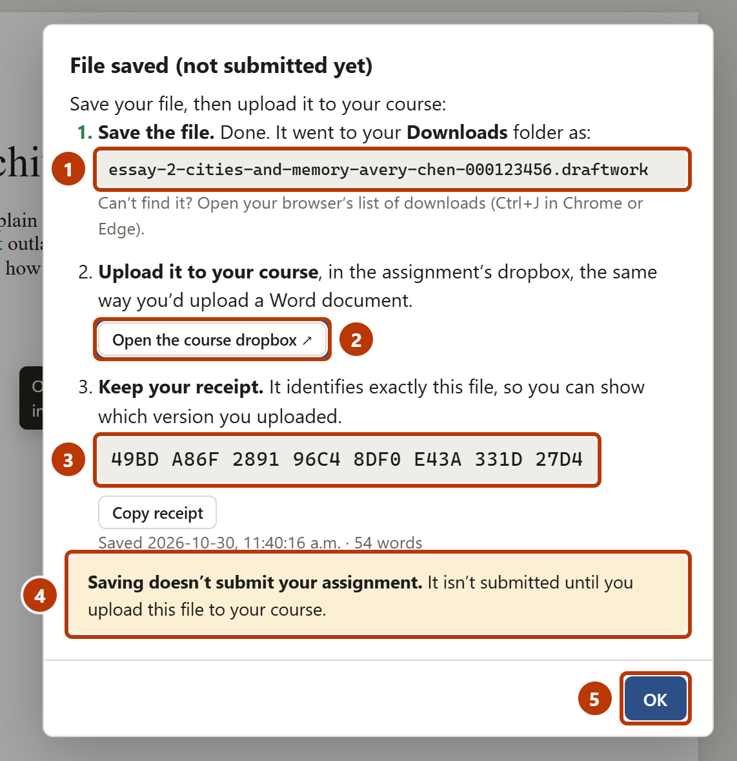
Figure 1. The window after you save your file
Number | Item | What it is for
1 | File name | The file to upload. It is in your Downloads folder.
2 | Open the course dropbox | Opens the dropbox, if your instructor added the link.
3 | Receipt | A code that identifies your file.
4 | Message | Upload the file to submit your assignment.
5 | OK | Closes the window.

If you need help
Problem | Do this
You cannot find the saved file. | Press Ctrl+J in Chrome or Edge to see your downloads.
You want to work on a different computer. | Save your file. On the other computer, open the link and click Continue from a file I saved….
You wrote more after you uploaded. | Save the file again and upload the new file.
Draftwork does not start. | Make sure that you are online. Close other tabs with this assignment. Try again.

For full instructions, see the Draftwork Student Guide, or click Help in the editor.

